Chapter 10, Problem 11.

Using nodal analysis, find i_{o}(t) in the circuit in Fig. 10.60.

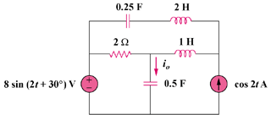

Figure 10.60
For Prob. 10.11.

